**DAYANANDA SAGAR COLLEGE OF ENGINEERING**

**(An Autonomous Institute affiliated to VTU, Belagavi – 590018, Approved by AICTE & ISO 9001:2015 Certified)**

**Accredited by National Assessment & Accreditation Council (NAAC) with ‘A’ grade & NBA**

 

**A Project Work Phase-1 Report**

**Design of H5 Transformerless Inverter for Photovoltaic System**

*Submitted in partial fulfilment for the award of degree of*

**Bachelor of Engineering**

**in**

**Electrical and Electronics Engineering**

***Submitted by***

**Name USN**

**Abhishek Kumar Tiwari 1DS19EE002**

**Akhilesh Kumar 1DS19EE006**

**Aniket Bharti 1DS19EE009**

**Mukul Mayur 1DS19EE050**

***Under the guidance of***

**Dr. M. Balamurugan**

Assistant Professor

Dept. of E&E Engineering

DSCE, Bengaluru

DSCE, Bengaluru **DEPARTMENT OF ELECTRICAL AND ELECTRONICS ENGINEERING**

**DAYANANDA SAGAR COLLEGE OF ENGINEERING**

**Shavige Malleshwara Hills, Kumaraswamy Layout**

**Bengaluru-560078**

**2022-23**

**DAYANANDA SAGAR COLLEGE OF ENGINEERING**

**(An Autonomous Institute affiliated to VTU, Belagavi – 590018, Approved by AICTE & ISO 9001:2008 Certified)**

**Accredited by NBA, National Assessment & Accreditation Council (NAAC) with ‘A’ grade**

**Shavige Malleshwara Hills, Kumaraswamy Layout**

**Bengaluru-560078**

**2021-2022**

**DEPARTMENT OF ELECTRICAL & ELECTRONICS ENGINEERING**



**CERTIFICATE**

Certified that the Mini Project report entitled **“Design of H5 Transformerless Inverter for Photovoltaic System**” carried out by **Abhishek Kumar Tiwari (1DS19EE002), Akhilesh Kumar(1DS19EE006),Aniket Bharti(1DS19EE009), and Mukul Mayur(1DS19EE050),** Bonafede students of **DAYANANDA SAGAR COLLEGE OF ENGINEERING**, an autonomous institution affiliated to VTU, Belagavi in partial fulfilment for the award of Degree of **Bachelor of Engineering in Electrical and Electronics Engineering** during the year **2022-2023.** It is certifiedthat all corrections/suggestions indicated for Internal Assessment have been incorporated in the Report. The **Project Work Phase-1 (19EE7ICPR1)** report has been approved as it satisfies the academic requirements in respect of Project work prescribed for the above said Degree.

**Signature of the Internal Guide Signature of the HOD**

**Dr. M. Balamurugan Dr. P.Usha**

**Assistant Professor Professor & HOD**

**Dept. of E&E Engineering Dept. of E&E Engineering**

**DSCE, Bengaluru DSCE, Bengaluru**

**Name of the Examiner                                                                Signature with date**

1. …………………….. …………………………
2. …………………….. ………………………...

**DAYANANDA SAGAR COLLEGE OF ENGINEERING**

**(An Autonomous Institute affiliated to VTU, Belagavi – 590018, Approved by AICTE & ISO 9001:2008 Certified) Accredited by NBA, National Assessment & Accreditation Council (NAAC) with ‘A’ grade Shavige Malleshwara Hills, Kumaraswamy Layout**

**Bengaluru-560078**

**2022-2023**

**DEPARTMENT OF ELECTRICAL & ELECTRONICS ENGINEERING**



**DECLARATION**

**We, Abhishek Kumar Tiwari(1DS19EE002),Akhilesh Kumar(1DS19EE006),Aniket Bharti(1DS19EE009),and Mukul Mayur(1DS19EE050),respectively, hereby  declare that the project work entitled “Design of H5 Transformerless Inverter for Photovoltaic System” has been independently done by us under  the guidance of ‘Dr. M. Balamurugan ’, Assistant Professor , EEE department and submitted in partial  fulfillment of the requirement for the award of the degree of Bachelor of Engineering in Electrical &  Electronics Engineering, at Dayananda Sagar College of Engineering, an autonomous institution affiliated to  VTU, Belagavi during the academic year 2022-2023.**

**We further declare that we have not submitted this report either in part or in full to any other university  for the award of any degree.**

**NAMES: USN:**

Abhishek Kumar Tiwari 1DS19EE002

Akhilesh Kumar 1DS19EE006

Aniket Bharti 1DS19EE009

Mukul Mayur 1DS19EE050

PLACE: DSCE, BANGALORE

**TABLE OF CONTENTS**

ABSTRACT ----------------------------------------------------- PAGE | 3

CHAPTER 1:

INTRODUCTION ---------------------------------------------- PAGE | 4

CHAPTER 2:

LITERATURE SERVEY AND------------------------------- PAGE | 5

GAP ANALYSIS

CHAPTER 3:

PROPOSED METHODOLOGY ----------------------------- PAGE | 8

CHAPTER 4:

PROJECT DESCRIPTION

*SIMULATION DESCRIPTION ----------------------------------------* PAGE | 12

*SOFTWARE DESCRIPTION ------------------------------------------* PAGE | 13

*CODE REVIEW ---------------------------------------------------------* PAGE | 14

CHAPTER 5:

RESULTS -------------------------------------------------------- PAGE | 15

REFERENCES -------------------------------------------------- PAGE | 16

**LIST OF FIGURES**

|  |  |  |  |
| --- | --- | --- | --- |
| **S.no** | **Name of Figure** | | **Page No** |
| 1 | Block diagram representation of model | | 8 |
| 2 | Simulation of Transformerless Inverter | | 10 |
| 3 | Block Diagram Representation of PID controller | | 11 |
| 4 | Schematics of the Software Chain | | 12 |
|  |  |

**ABSTRACT**

There are two types of sources for electrical power generation.One is conventional and other is non-conventional.Today to generate most of electrical power conventional sources like coal,gas,nuclear power generators are used, which is not good for the environment.So some of the electrical power should be generated by non-conventional energy like solar,wind.With the continuously reducing the cost of Photovoltaic (PV) power generation and the further need of energy crisis, PV power generation technology obtains more and more application.Importances in the present day scenario are pollution free energy, reduction in greenhouse gasses,energy reproduction in remote locations.

To use the solar PV source for single-phase AC applications, H5 converter topology has been proposed. Dual input DC-DC boost converters that integrate the solar panel and a battery will regulate the required output DC voltage. Furthermore, for the AC applications of having small power and High power, the H6 topology of single-phase transformerless inverter is preferred because of less leakage current. To validate the proposed technique's feasibility, the MATLAB simulation is performed for the whole process and a prototype is to be designed that validates the converter's results and performance. The simulation is to be carried out in MATLAB/Simulink software.

**CHAPTER 1**

**INTRODUCTION**

Among all renewable energy sources, photovoltaic (PV) energy is generally rated as the most attractive and sustained source because it is available throughout the year. In the future, more than 45% of the needed power is anticipated to be generated by PV arrays.

PV arrays can deliver energy to stand-alone applications or utility grids. Delivering power to a utility grid is becoming an increasingly popular option. To connect PV arrays to the utility grid, the DC/AC inverter followed by a line transformer is used.

These transformers have many drawbacks including high system cost and decreased efficiency. The transformers are very large and heavy. Without a line transformer, leakage current forms through parasitic capacitances between the PV array and the ground . The leakage current results in radiated interfering problems and other severe safety issues.

To resolve the issue concerning leakage current, several solutions can be used. Another approach to minimize leakage current is to employ transformerless inverters .The basic idea of transformerless inverters is to disconnect the dc side (PV array) from the ac side (inverter and grid) in freewheeling modes.

When employing transformer-less systems,considered the maximum power drawn from the PV system. Hence, it is important to follow up the maximum power to improve the utilization factor of the PV system. A maximum power point tracker is also used to continuously draw maximum power from the PV array.

The proposed system featuring a boost converter inserted between the PV panel and the H5 inverter. The boost converter is used as an impedance matching device between the PV array on one side and the H5 inverter and the grid on the other side. It is designed to operate at continuous conduction mode, such that the PV current is continuous at the MPPT value.

**CHAPTER 2**

**LITERATURE SURVEY**

* **An H5 Transformerless Inverter for Grid Connected PV Systems with Improved Utilization Factor and a Simple Maximum Power Point Algorithm**

*Hani Albalawi Department of Electrical Engineering, Faculty of Engineering, University of Tabuk, Tabuk 47913, Saudi Arabia; and Sherif Ahmed Zaid Department of Electrical Power, Faculty of Engineering, Cairo University, Cairo 12613, Egypt.*

Due to their small size, minimum cost, and great efficiency, photovoltaic (PV) grid-connected transformerless inverters have been developed and become famous around the world in distributed PV generators systems. One of the most efficient topologies of the transformerless inverter family is H5 topology. This inverter extracts a discontinuous current from the PV panel, which conflicts with the operation at maximum power point tracking (MPPT) conditions while the utilization factor of the PV degrades. This paper proposes improved H5 topology featuring a boost converter inserted in the middle between the PV panels and the H5 inverter. The design of the boost converter is planned to operate at continuous conduction mode to guarantee MPPT conditions of the PV. A new and simple off line MPPT algorithm is introduced and performance factors like efficiency and utilization factors of the proposed and convention H5 topology are compared. The simulation results indicate that the proposed system provides a preferable utilization factor and a simpler MPPT algorith**.**

* **Boost Converter With MPPT and PWM Inverter For Photovoltaic System.**

*Tejan L1 and Divya K Pai1* International Journal of Electrical and Electronics Engineering & Telecommunication (Volume-7, Issue-3, March 2020).

This paper presents boost converter with maximum power point tracking technique for photovoltaic system to extract maximum power from solar panel, and the system is connected with battery storage system, and cascaded with PWM inverter along with an RLC second order passive filter which outputs a stable AC voltage, which is not possible in traditional PV inverter system.

* **Design of Single Phase Transformerless Inverter.**

*Durgalakshmi , Nivetha , Sanjay , Vignesh International Research Journal of Engineering and Technology (IRJET). Volume: 06 Issue: 03 | Mar 2019.*

The transformerless inverters used in the grid connected photo voltaic (PV) system induce leakage current due to the absence of galvanic isolation and unstable common mode voltage. The leakage current is mainly depending on Common Mode Voltage (CMV).This can be eliminated for all modes of operation. Proper selection of common mode voltage (CMV) depends on selection of inverter topology. To eliminate the leakage current, the common mode voltage must be kept constant during all operation mode. . Even though, the leakage current can be reduced by using the H5 topology, it is still considered high due to the existence of junction capacitance in the switches during the freewheeling mode. The simulation of the proposed topology is carried out in MATLAB and validated experimentally. The results show that the H5 has lower leakage current as compared to the H6 and HERIC.

**Gap Analysis:**

* Transformerless inverters are generally more efficient than conventional inverters because they are able to avoid internal energy losses and extra component costs.
* Due to the absence of a transformer, transformerless inverters are light, compact, and relatively cheaper than conventional inverters.
* Since transformerless inverters use electronic switching rather than mechanical switching, the amount of heat and buzzes produced by standard inverters is greatly reduced. This, in some cases, removes the need for cooling fans.
* Traditional inverters work through only one powerpoint, which means panels that are performing at lower frequencies will lower DC output for the entire system. But with transformerless inverters, solar panels can be installed in two different directions (i.e. north and west) on the same rooftop and generate DC output at separate peak hours with optimal effects.

**CHAPTER 3**

**PROPOSED METHODOLOGY**

* This system has two distributed generation units and those are battery and Photovoltaic energy. When the PV source is available, it charges the battery as well as provides energy to the load. When PV source is not available or less solar irradiation then the batteries will charge through a secondary AC source which is converted to DC by the help of a rectifier circuit.
* The Dual DC-DC buck-boost converter is used to increase the DC voltage with integration of solar panel and batteries.
* Further for AC application H6 or H5 topology of single-phase transformerless inverter is preferred because of less leakage current.which help to reduce weight of the solar inverter.
* To validate the proposed technique's feasibility, the MATLAB simulation is performed for the whole process and a prototype is to be designed that validates the converter's results and performance. The simulation is to be carried out in MATLAB/Simulink software.
* **Maximum Power Point Tracking (MPPT):**

MPPT works on Maximum power transfer theorem which states that output power will be maximum if input parameters and output parameters are matched. The principle of working is as voltage and current of PV cells will be varying based on solar parameters the MPPT will be designed in such a way that it finds maximum power point of cell for different voltage and current by estimating power and gives signal to control boost converter to work in maximum efficiency condition.

* **Buck-Boost Converter:**

The bidirectional Buck-Boost converter topology is composed of an inductor, two capacitors, and two switching transistors. The diode of the switching transistor plays an important part in the circuit design, allowing the current to flow bidirectionally from the DC link to the battery storage device and vice versa.

* **H6 Type Single Phase Transformerless Inverter:**

After regulating the required output voltage, the buck-boost converter feeds it to the single-phase transformerless inverter, converting this DC voltage into AC for AC power applications.

**Block Diagram Representation:**

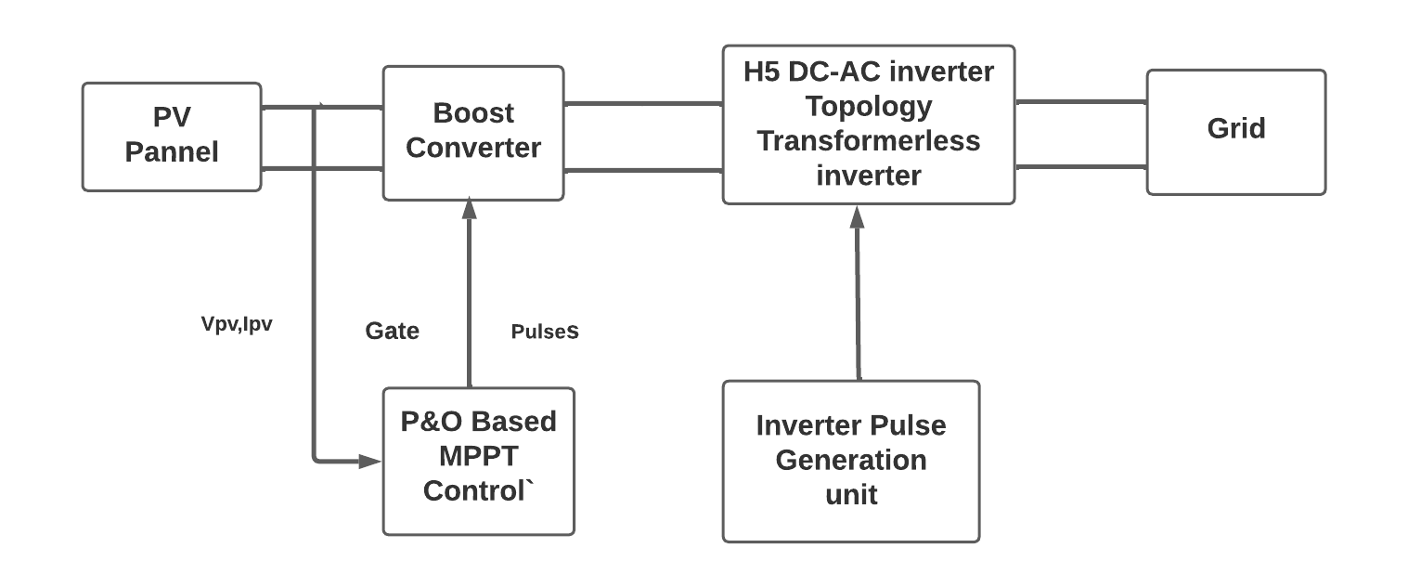

Fig 1- Block diagram representation of model

**CHAPTER 4**

**PROJECT DESCRIPTION**

# Software Description:

* **MATLAB**

MATLAB is a programming platform designed specifically for engineers and scientists to analyze and design systems and products that transform our world. The heart of MATLAB is the MATLAB language, a matrix-based language allowing the most natural expression of computational mathematics.

Simulink is a block diagram environment for multidomain simulation and Model-Based Design. It supports system-level design, simulation, automatic code generation, and continuous test and verification of embedded systems. Simulink provides a graphical editor, customizable block libraries, and solvers for modeling and simulating dynamic systems. It is integrated with MATLAB, enabling you to incorporate MATLAB algorithms into models and export simulation results to MATLAB for further analysis.

Here we are using the MATLAB libaray Simscape Electrical Specialized Power Systems allows you to build and simulate electrical circuits containing linear and nonlinear elements. Explore the Simscape Electrical Specialized Power Systems library.Learn how to build a simple circuit from the SimscapeElectrical Specialized Power Systems library.Interconnect Simulink blocks with circuit.

Simscape Electrical helps you develop control systems and test system-level performance. You can parameterize your models using MATLAB variables and expressions, and design control systems for electrical systems in Simulink. You can integrate mechanical, hydraulic, thermal, and other physical systems into your model using components from the Simscape family of products. To deploy models to other simulation environments, including hardware-in-the-loop (HIL) systems, Simscape Electrical supports C-code generation.

**Simulation Description:**

* A simulation imitates the operation of real world processes or systems with the use of models. The model represents the key behaviours and characteristics of the selected process or system while the simulation represents how the model evolves under different conditions over time.

Simulations are usually computer-based, using a software-generated model to provide support for the decisions of managers and engineers as well as for training purposes. Simulation techniques aid understanding and experimentation, as the models are both visual and interactive.

Simulation systems include discrete event simulation, process simulation and dynamic simulation. Businesses may use all of these systems across different levels of the organisation.

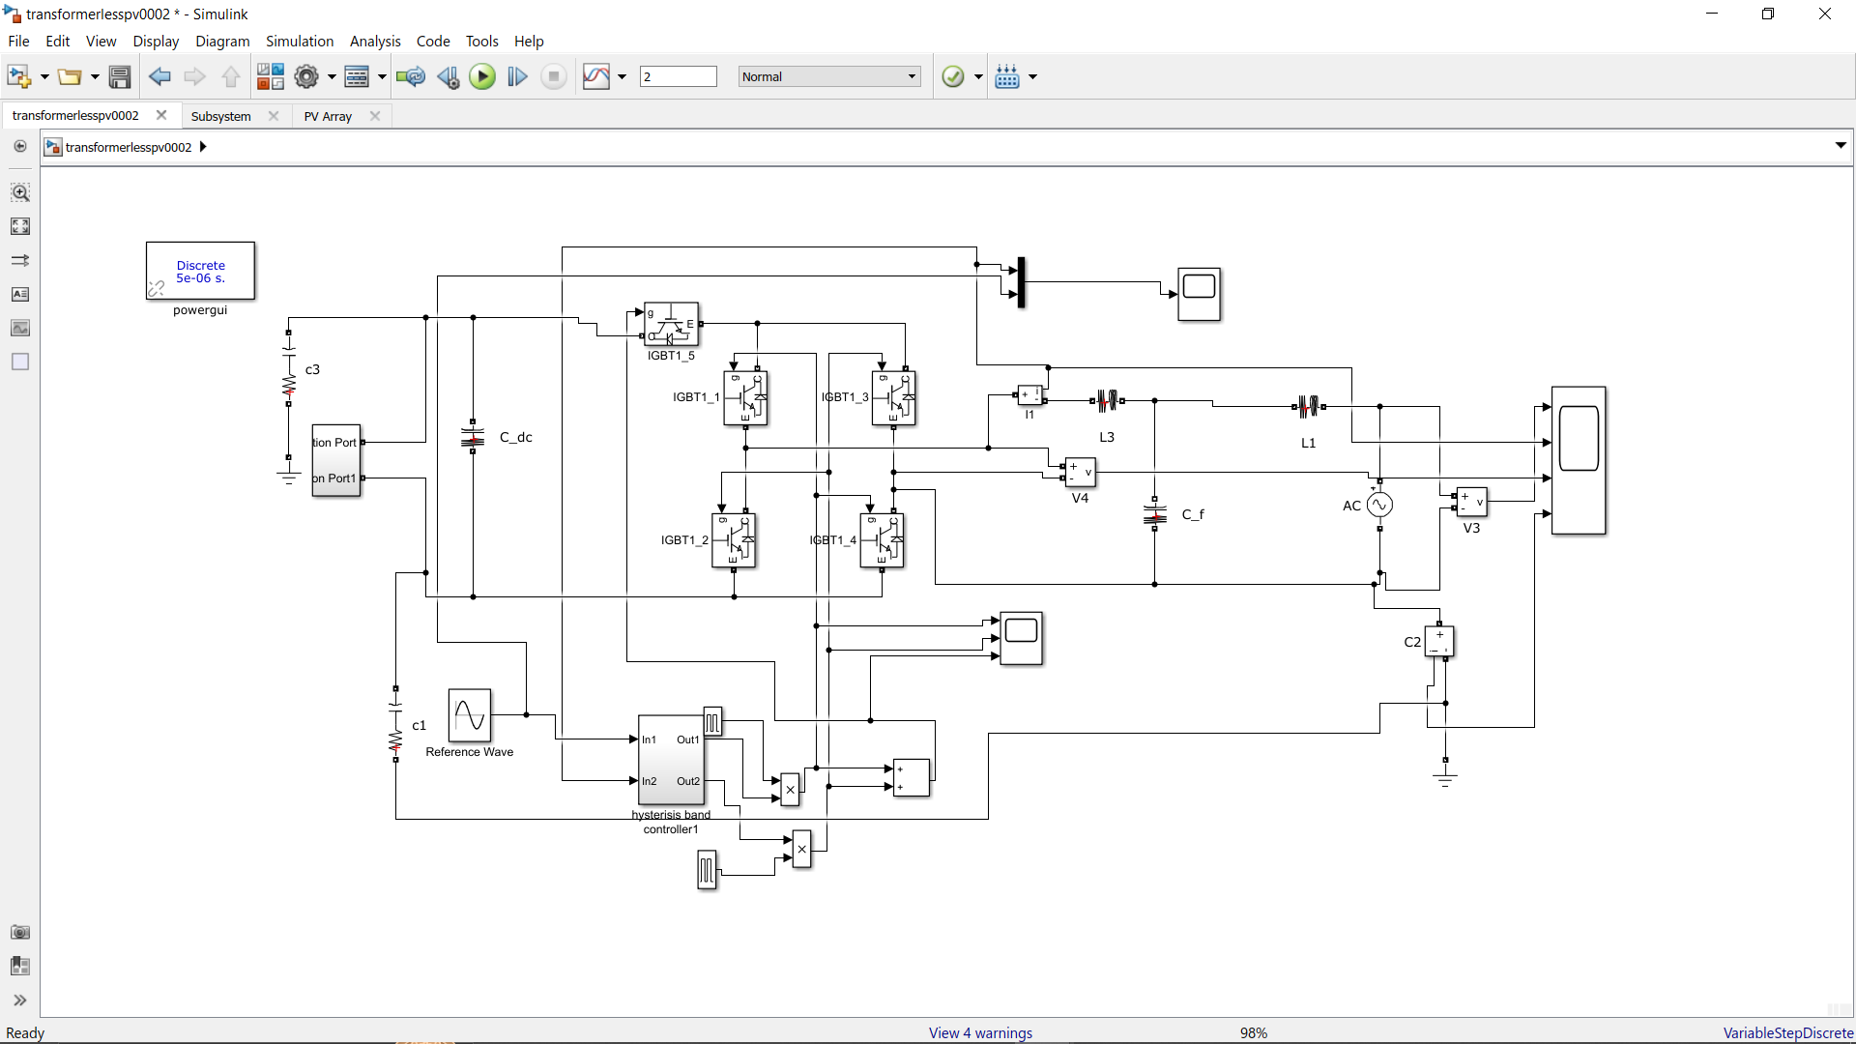

Fig 2-Simulation of Transformerless Inverter

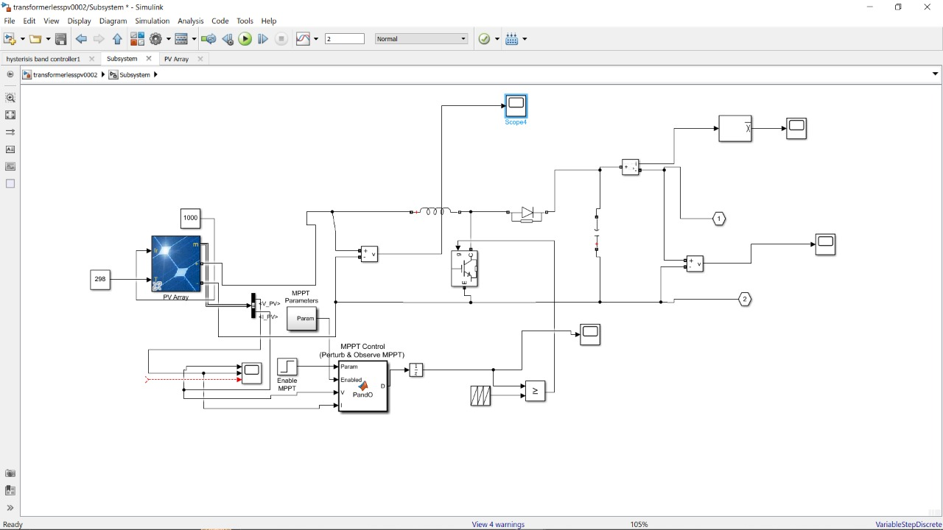

Fig-3 Simulation of Solar Subsystem with MPPT and Converter

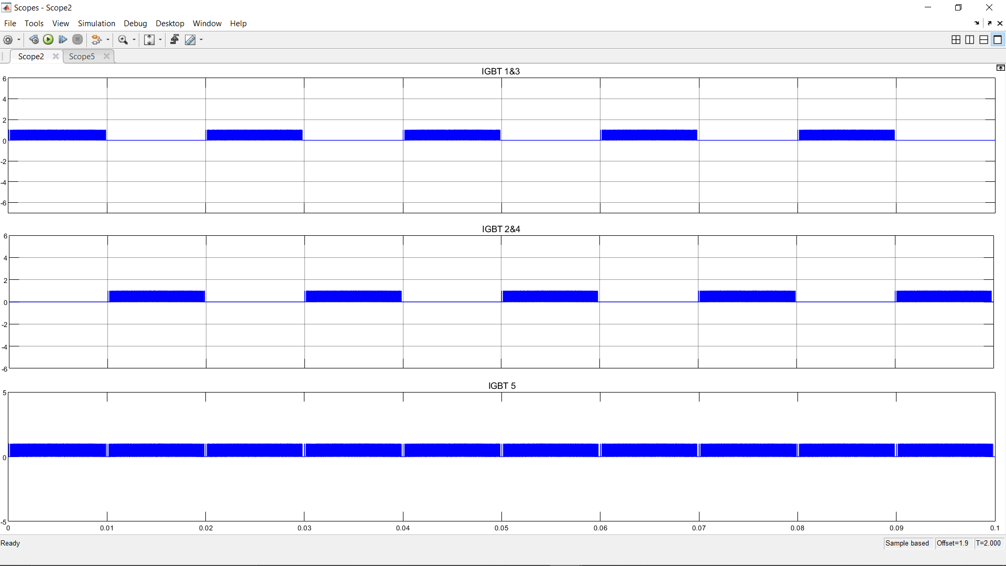

Fig-4 Pulse genration for IGBT(Inverter)

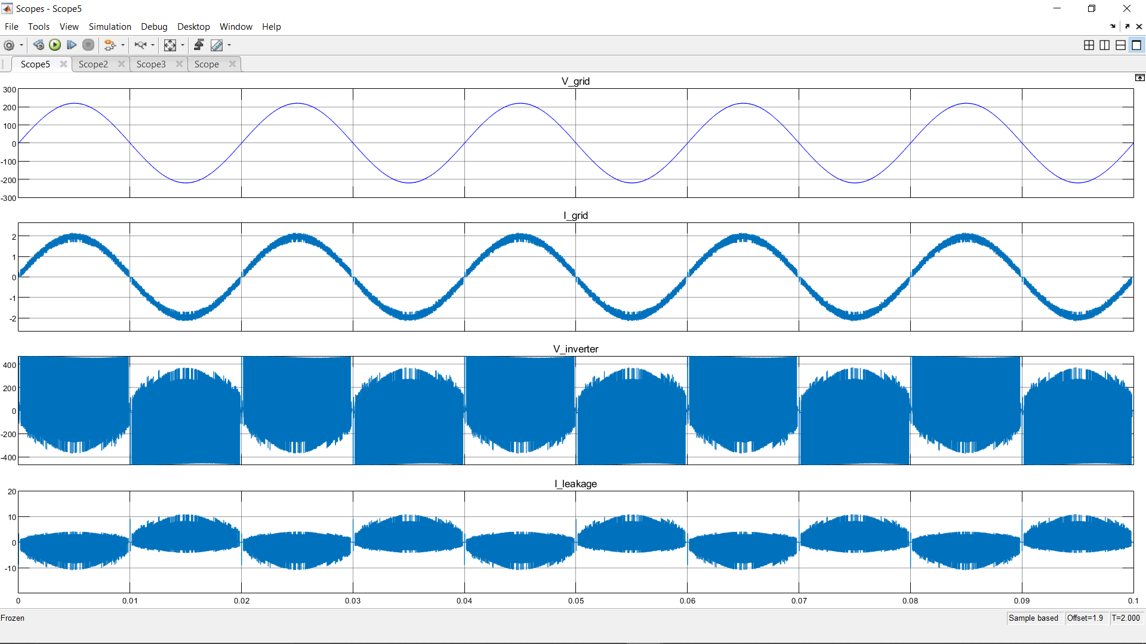

Fig-5 Inverter and Grid Output voltage and current Scope

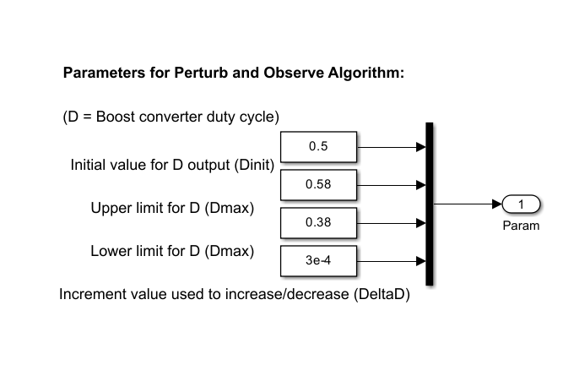

Fig-6 Parameters for Perturb and Observation Algorithm

**Code Description:**

function D = PandO(Param, Enabled, V, I)

% MPPT controller based on the Perturb & Observe algorithm.

% D output = Duty cycle of the boost converter (value between 0 and 1)

% Enabled input = 1 to enable the MPPT controller

% V input = PV array terminal voltage (V)

% I input = PV array current (A)

% Param input:

Dinit = Param(1); %Initial value for D output

Dmax = Param(2); %Maximum value for D

Dmin = Param(3); %Minimum value for D

deltaD = Param(4); %Increment value used to increase/decrease the duty cycle D

% ( increasing D = decreasing Vref )

persistent Vold Pold Dold;

dataType = 'double';

if isempty(Vold)

Vold=0;

Pold=0;

Dold=Dinit;

end

P= V*I;

dV= V - Vold;

dP= P - Pold;

if dP ~= 0 & Enabled ~=0

if dP < 0

if dV < 0

D = Dold - deltaD;

else

D = Dold + deltaD;

end

else

if dV < 0

D = Dold + deltaD;

else

D = Dold - deltaD;

end

end

else D=Dold;

end

if D >= Dmax | D<= Dmin

D=Dold;

End

**Work Completed:**

* Simulation of H5 transformer-less Inverter using Matlab software.

* Simulation of PV array with MPPT(P&O).

* Simulation of Boost converter.

**Work To be Completed :**

* Design calculation for H5 Inverter.

* Development of lab scale prototype of H5 inverter.

**REFERENCES:**

1. Tejan L and Divya K Pai, “Boost Converter With MPPT and PWM Inverter For Photovoltaic Systems” International Journal of Electrical and Electronics Engineering & Telecommunication (Volume-7, Issue3, March 2020)

2.Gaurav Arora, Neha Aggarwal, Debjoyti Sen, Prajwal Singh, IMSEC Ghaziabad “Design of Solar Power Inverter” International Advance Research Journal In science , Engineering and technology (IARJ SET)(Vol. 3, No. 1, April 2020, 12-19)

C. Schuss, et al., "Impacts on the Output Power of Photovoltaics on Top of Electric and Hybrid Electric Vehicles," in IEEE Transactions on Instrumentation and Measurement, vol. 69, no. 5, pp. 2449-2458, May 2020, DOI: 10.1109/TIM.2019.2962850.

Z. Q. Zhu and S. Cai, "Hybrid excited permanent magnet machines for electric and hybrid electric vehicles," in CES Transactions on Electrical Machines and Systems, vol. 3, no. 3, pp. 233-247, Sept. 2019, DOI: 10.30941/CESTEMS.2019.00032.

E. Kabir, et al., "Solar energy: Potential and future prospects," Renewable and Sustainable Energy Reviews, 2018, 82, pp.894-900

S. Hussain et al., "Simulative Analysis of Power Conversion System for Hybrid Electric Vehicles Based on Dual Input Sources Including Charging From Solar Panel," Pakistan J Engg & Tech, vol. 3, no. 03, pp. 14-19, Dec. 2020.

Muhammad Nasir Khan, Syed K. Hasnain, Mohsin Jamil, Sameeh Ullah, "Electronic Signals and Systems Analysis, Design and Applications International Edition," in Electronic Signals and Systems Analysis, Design and Applications: International Edition , River Publishers, 2020.

L. E. Zubieta, "Are Microgrids the Future of Energy?: DC Microgrids from Concept to Demonstration to Deployment," in IEEE Electrification Magazine, vol. 4, no. 2, pp. 37-44, June 2016.

H. Cai, X. Ji and W. Wei, "Decentralized autonomous operation for islanded photovoltaic-based DC microgrids," 2017 36th Chinese Control Conference (CCC), Dalian, 2017, pp. 10570-10575.

M. Nasir, H. A. Khan, A. Hussain, L. Mateen and N. A. Zaffar, "Solar PV-Based Scalable DC Microgrid for Rural Electrification in Developing Regions," in IEEE Transactions on Sustainable Energy, vol. 9, no. 1, pp. 390-399, Jan. 2018.

**DAYANANDA SAGAR COLLEGE OF ENGINEERING**

**(An Autonomous Institute affiliated to VTU, Belagavi – 590018, Approved by AICTE & ISO 9001:2008 Certified)**

**DEPARTMENT OF ELECTRICAL & ELECTRONICS ENGINEERING**

**Major Project Course Outcomes and Mapping**

**Course Outcomes: The Students would be able to**

|  |  |
| --- | --- |
| **CO1** | **Identify a topic related to present day challenges.** |
| **CO2** | **Analyze technical aspects of the chosen project with a systematic approach to find a feasible solution for the chosen work.** |
| **CO3** | **Use/ implement  modern Engineering tools/ technologies to get optimized results** |
| **CO4** | **Demonstrate an ability to work in teams.** |
| **CO5** | **Develop presentation ,communication and report writing skills** |

|  |  |  |  |  |  |  |  |  |  |  |  |  |  |  |  |  |
| --- | --- | --- | --- | --- | --- | --- | --- | --- | --- | --- | --- | --- | --- | --- | --- | --- |
| **Group No.** | **Project Title** | **PO1** | **PO2** | **PO3** | **PO4** | **PO5** | **PO6** | **PO7** | **PO8** | **PO9** | **PO**  **10** | **PO**  **11** | **PO**  **12** | **PSO1** | **PSO2** | **PSO3** |
| A-10 | *Design of H5 Transformerless inverter for Photovoltaic System* | ü | ü | ü | ü | ü |  |  | ü | ü | ü | ü | ü | ü | ü | ü |